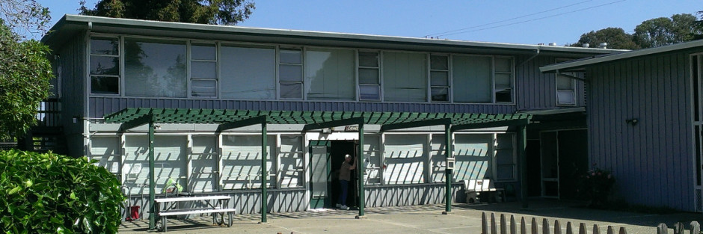

South Hayward Parish
May 2016 Newletter
A collective of local faith communities

Annual Meeting May 21
South Hayward Parish will be conducting its Annual Meeting on Saturday May 21 at 10:00 a.m. The theme of the Annual Meeting is “It Takes Quarters”, which is a celebration of SHP’s new laundry room, and a commitment to help clients pay for bus transportation to various appointments. Executive Director Sue Merrill will present the Parish’s annual report, and there will be program reports. Last but not least, the members will elect a slate of officers for 2016-17. The Board’s nominees include incumbents Daryl Berman as President, Terry Owen as Treasurer and Tom Spitzer as Secretary. The Board has nominated Leo Wilkerson to serve as vice-Chair, to replace Keith Burnett who is stepping down after two years of dedicated service. Oh, and healthy snacks will be served.
Cooking Classes
Cooking classes are taking place at SHP every second Thursday and fourth Friday through October.
Let Thy Garden Grow!
The SHP garden is now undergoing its Spring planting, with about forty-four crops now in the ground. Most of what you see there now are herbs such as sage, French tarragon and salvia. The main food crops such as corn, tomatoes and green beans are in the process of getting planted.

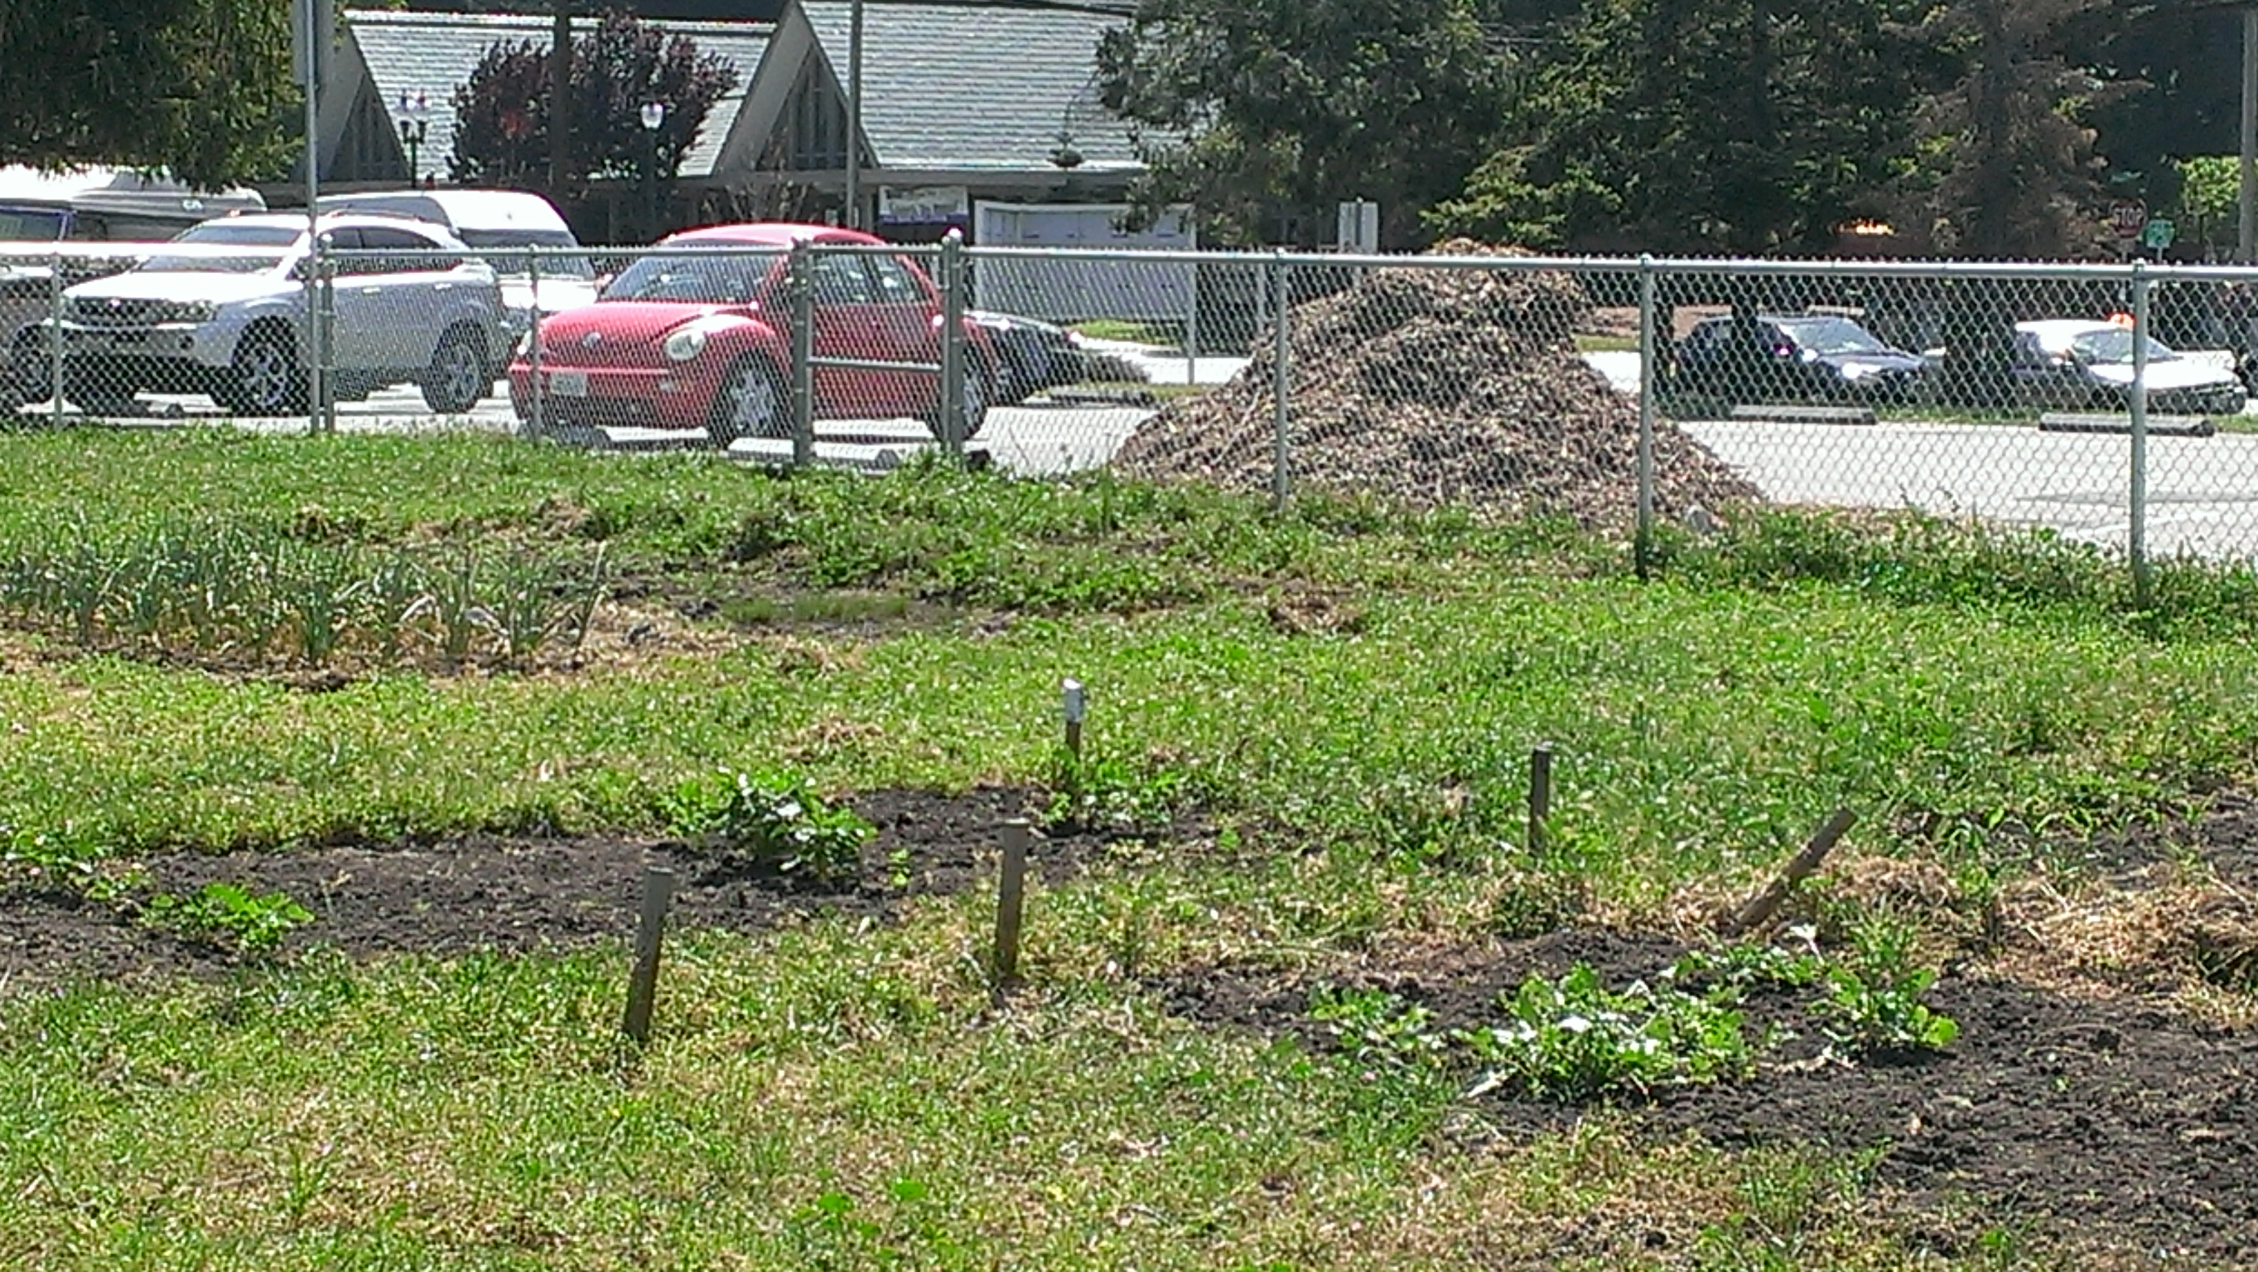
Much of what is being planted are food crops that many cultures use in common. However, there will be other crops planted geared towards pacific cultures or regions. The goal is to have foods that available that our diverse communities are comfortable with as well as to introduce new foods to those unfamiliar with some of the crops.
There have been several harvests since January that have supplied produce to Pantry clients. In addition to the harvested crops, clients have received tours of the garden, samples of herbs grown in the garden, and extra seedlings that were not going to be planted.
Because of the rain this is turning out to be a good year for the garden. We are expecting we will have grown over seventy different crops by year end!
Sue’s Snippets
We have had some complaints from neighbors, so we can no long allow anyone to sleep on site except in the shelter. You will see signs go up indicating that we prohibit parking of non-running cars on the site.
In the past few months, we have updated the SHP web site so that it works on phones and tablets, and we have re-invigorated our social media efforts. Like us on Facebook, follow us on Twitter and check us out on Instagram!
Food Pantry
South Hayward Parish
27287 Patrick Avenue
Hayward, CA 94544
(510) 785-3663
At the beginning of April, the food program still had a balance of $8100 for this fiscal year. The Pantry plans to spend this by the first week of June, largely on canned and other non-perishable goods. During this period, the Program Coordinator Ralph Morales would welcome volunteers to come help unload and put food in storage.
There have been days when the Pantry has served over one hundred families, and people on both sides of the distribution table are feeling good about having enough chicken, peanut butter, oatmeal, rice, beans and milk for all the households that come through.
Betty’s Bites

We’re happy to see spring, but thankful that we were able to serve so many people needing shelter on cold and rainy nights. We set a record for how many nights the winter warming shelter was open this year (45 nights). The shelter is gaining recognition as one of the few places in Hayward people can come sleep safely and comfortably when the weather is cold and wet. Betty especially calls out Our Lady of Grace for the donated meals that enabled serving hot meals on all the shelter nights!
New Washer Dryer!!!
Betty is thrilled that SHP now has a very respectable laundry room complete with a washer and dryer. At the April Board meeting, she called it “a gift from heaven.” The washer and dryer and the new shelving and cabinets were donations, and we paid for the necessary plumbing and electrical improvements with funds from a recent bequest. With all the showers and all the shelter nights, there is a great deal of laundry that needs to get done. Having the washer and dryer on site sure beats having to take the laundry to somebody’s house (usually Betty’s!).
What We Need Next
In addition to general purpose donations, which we always need, we are looking for special purpose funding for bus passes. Bus passes enable clients to get to social security and health appointments, job interviews, and other places they need to get to. We can buy a pack of forty two passes for the discounted price of two dollars. Consider making donations of $42 or $84 to address this need.
Lately, we’re seeing an increased need for diapers, wipes, and formula, so donations of those would be welcome.
We need more students for our GED programs. You may not know it, but SHP runs a GED program, but we are short on students at the moment.
Challenge Grant
The James Cameron Forsyth Foundation has made a new challenge grant to the South Hayward Parish of Two Thousand Dollars, under the following conditions:
- The SHP will undertake fundraising activities to raise Four Thousand Dollars on its own , to match the Foundation’s grant.
- The $4,000 raised by SHP is to be used for the Homeless Shelter which the Foundation previously funded.
- The foundation’s grant money (i.e. $2,000) is specifically designated for the SHP’s Language and Community Advocacy Clinic.
- When asked the reason for this new grant, the foundation’s founder and widow of James Cameron Forsyth expressed her late husband’s lifelong support for the work of the South Hayward Parish and those affected by poverty and homelessness.
ANUNCIO DE DESAFÍO DE SUBVENCIÓN
- La fundación de James Cameron Forsyth ha emitido un nuevo desafío de subvención a la South Hayward Parish de dos mil dólares, bajo los siguientes términos:
- La South Hayward Parish obtendrá donativos de cuatro mil dólares entre esta fecha y el 15 de mayo de 2016, para igualar la subvención de la fundación.
- Del dinero obtenido, la cantidad obtenida (es decir, $4,000) será utilizada para el asilo para los sin casa, que ya anteriormente la fundación financió.
- El dinero de la subvención (es decir, $2,000) está designado en particular para el Consultorio de la South Hayward Parish, es decir, la Language and Community Advocacy Clinic.
- La fundadora de la fundación y viuda de James Cameron Forsyth, cuando se le preguntó el porqué de esta nueva subvención, habló del apoyo de su difunto esposo hacia el trabajo de la South Hayward Parish y todos aquéllos afectados por la pobreza y la falta de vivienda.

